EIO2 FINAL WRITTEN EXAM SPRING 2010

STUDENT’S NAME :

GRADE : ….. /50 GRADE : ….. /25

You will deal with questions A and B. Then you will choose between questions C and D.
IMPORTANT! You will write your answers to each question on a separate sheet.

A: [20 marks]

A.1 THE INDUSTRIAL REVOLUTION : landscapes and processes.

- Describe, compare and interpret these two pictures. What is the main process
suggested through these pictures ?

2- Basing your comment on these two pictures, how can you explain the rapid
industrialization of Great Britain during the Industrial Revolution ? (about 80 words)
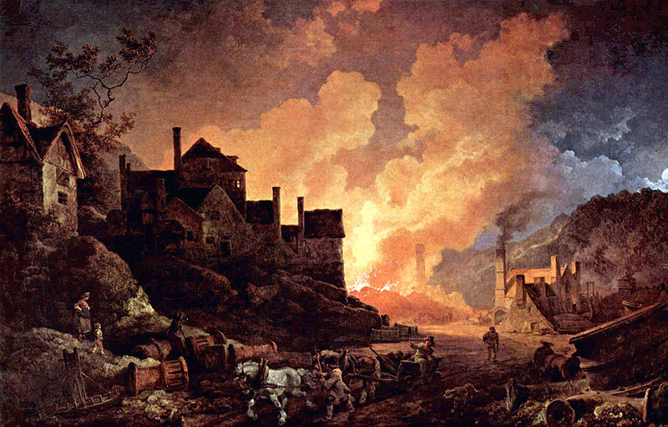

Coalbrookdale, engraved by William Pickett, c.1805 by Philippe de Loutherbourg / Private Collection.

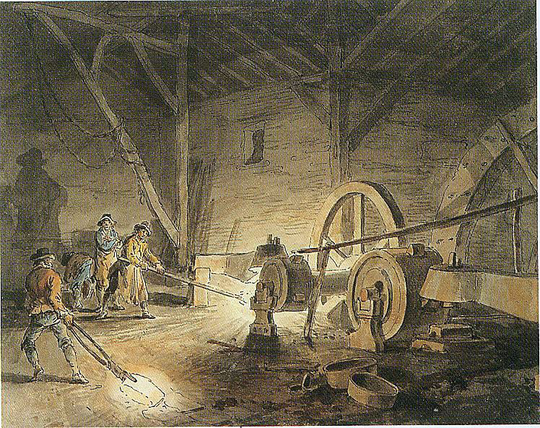

Painting from Julius Caesar Ibbetson, 1789.

A-2

- Write the names of the different elements indicated on this drawing.
(Write them directly on the pictures)

- Explain the mechanisms and functions of this engine. Who invented it ?
- What was the role of this machine during the industrial Revolution ?

1

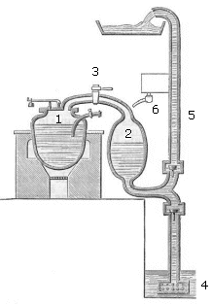

2

B: MILLING [ 20 marks ]

1) Heage Windmill in Derbyshire, built in 1797, is shown in Figure 1. It incorporates a number of technological advances that were made during the 18th and 19th centuries that made the Miller’s life easier. Typical problems that required the Miller’s constant attention until then were:
- controlling the transmission system so that changes in the windspeed would not result in changing the “stone speed”. The same system allowed the Miller to adjust the transmission speed without stopping the sails – see Figure 2. You might also like to think about this system’s ability to protect the windmill from gusts (strong sudden wind).
Using this evidence, try and describe in more detail, in about 150 words, the way this mechanism helped the Miller.
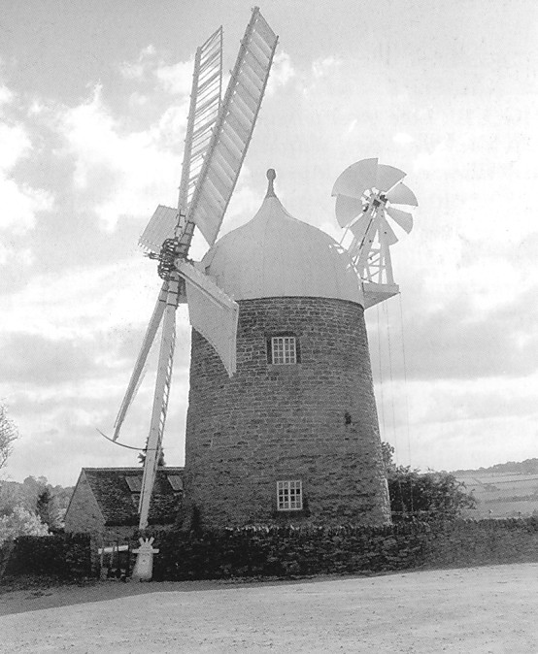
[10 marks]
Figure 1

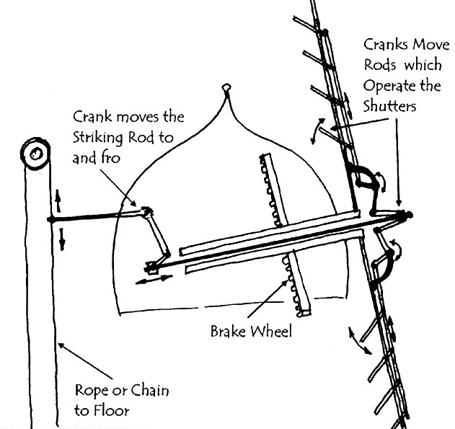
Figure 2

2- Complete the table below, matching the titles to the appropriate components. [4 marks]
Component | Insert  Corresponding  Letter
- Pit wheel
- Wheel shaft
- Crown Wheel
- Stone nut
- Top stone driven from below
- Auxiliary drives
- Sluice: power control
- Spur wheel
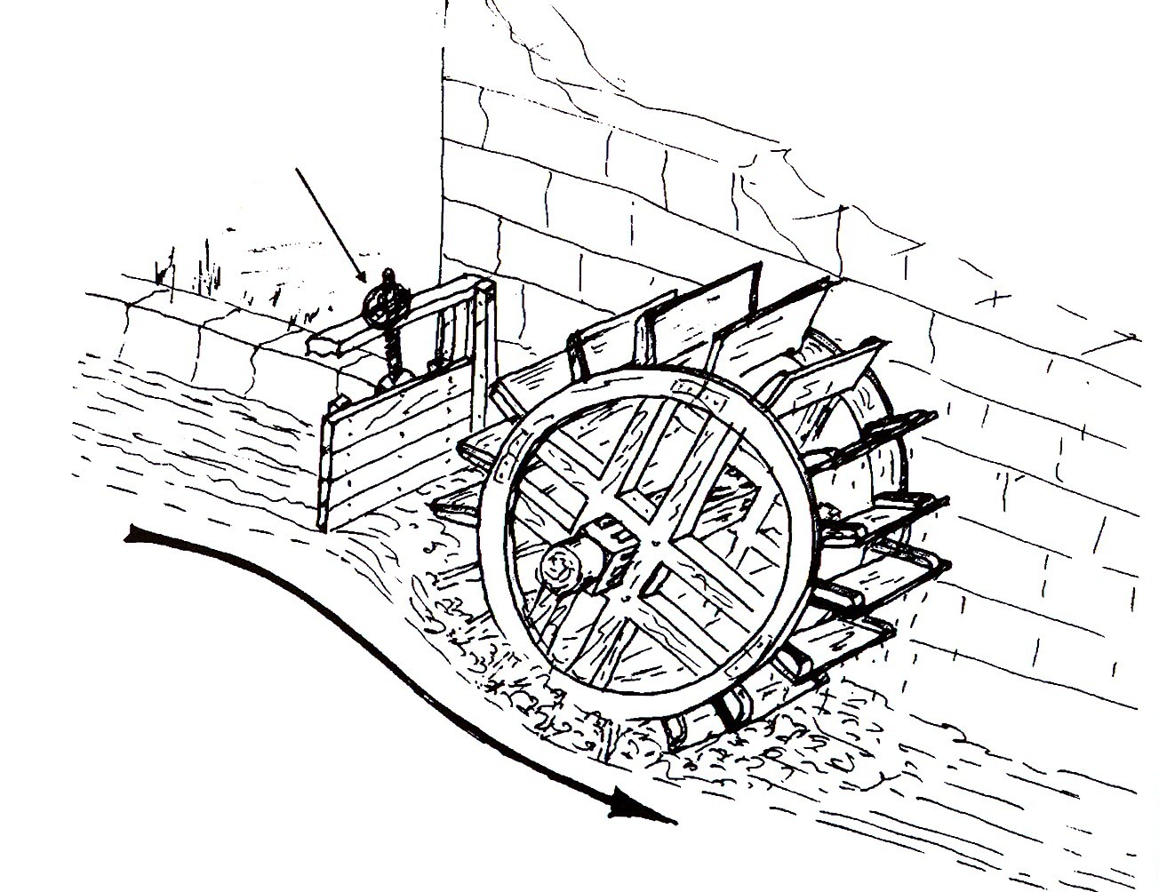
A
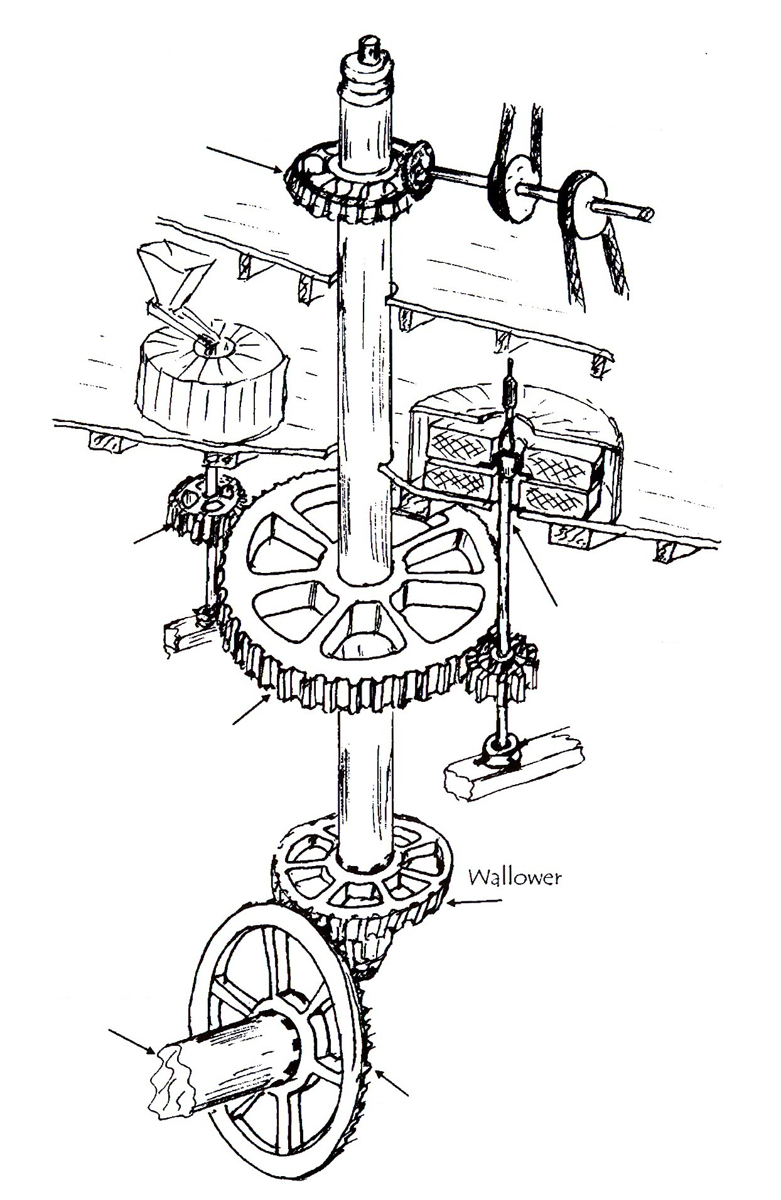
B
C
D
E
F
G
H

3) Complete the table below by naming the different waterwheel types and briefly describing their characteristics. You might like to consider the conditions they are appropriate for, how they use the water’s energy and what circumstances may limit their efficiency. [ 6 marks]

a)  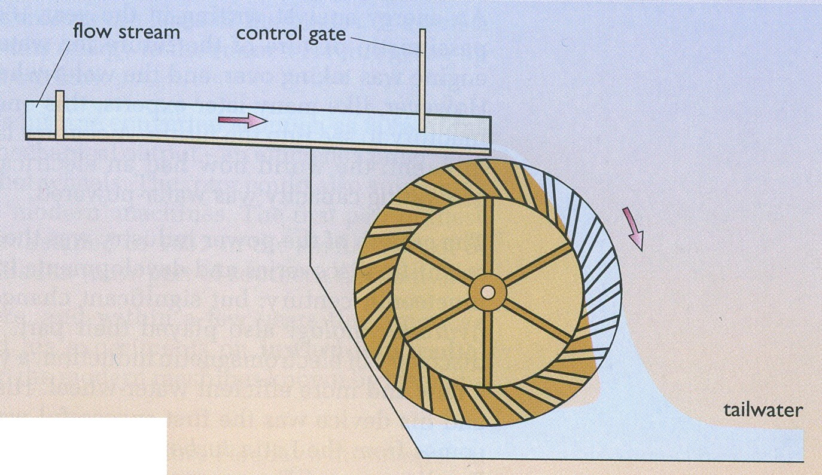 | Waterwheel type:  Characteristics:
b)  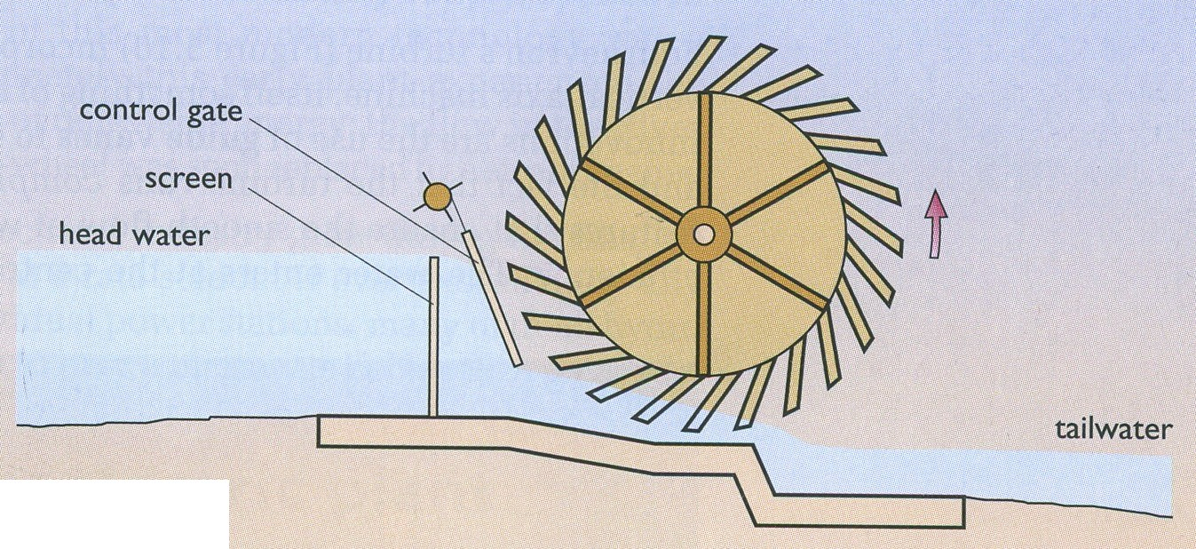 | Waterwheel type:  Characteristics:
c)  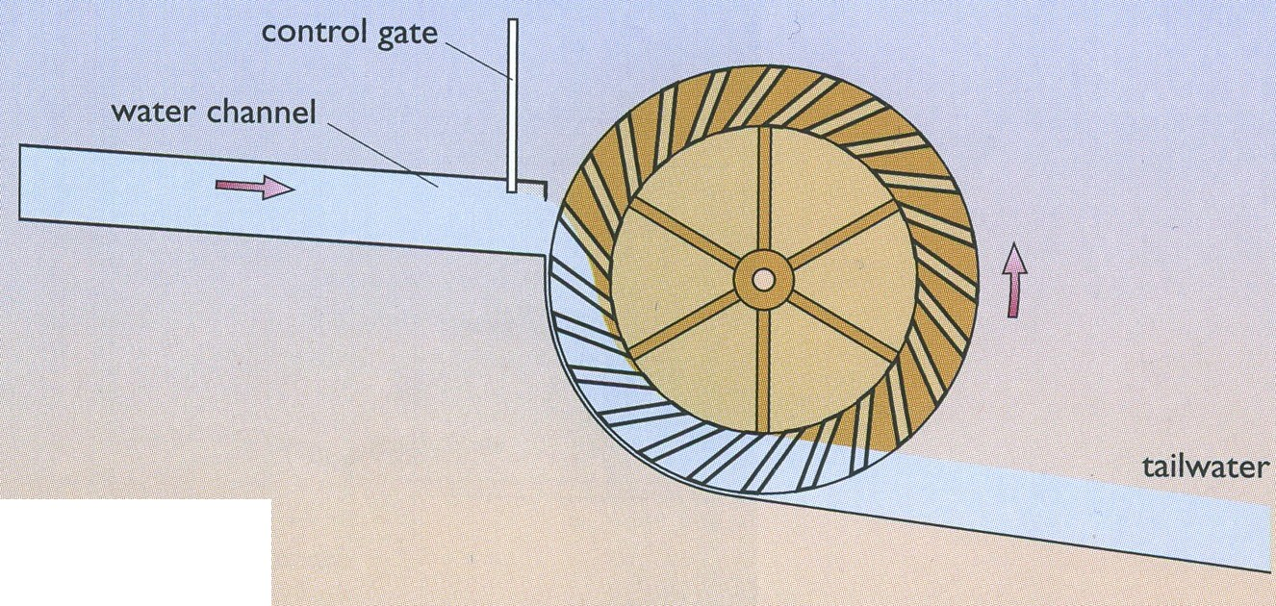 | Waterwheel type:  Characteristics:

!!!!! Do either C or D.

C CIVIL ENGINEERS [ 10 marks ]

The father and son teams of Marc and Isambard Brunel and George and Robert Stephenson were prominent civil/mechanical engineers of the early 19th century and their work was critical to engineering development, particularly in the field of transport and transport infrastructures.
Take one example of an engineering project, which may have been either a success or a failure, that one of the Brunels or Stephensons worked on and answer the following:
1. Describe in as much detail as you can the project itself. What did it consist of? What was innovative in it? What were the results or outcome of the work? What impact did it have, if any, on industry/ transportation systems/ society/ future development? You should use sketches (des croquis) to help describe the project. (100-150 words)
2. What can you say about the engineer himself? What was his background? What was his engineering style or working method? Was this style reflected in the project you have exposed? What other projects did he achieve? (50 words)

D CHILD LABOUR [ 10 marks ]

- You will find below the description of some of the tasks performed by young children in the British industry in the first half of the 19th century. Give the word used to refer to each task.

In the textile mills, …………………………..were used to pick up the loose cotton from under the machinery and sweep under the wheels.

As they had *nimble fingers, children were used as ……………………… to tie the broken threads together.
*nimble = agiles

In the mines
Operation that consisted in opening and closing the doors which controlled the flow of air underground: ………………..

Pulling the loaded wheeled containers for coal : …………………………

2- Why were so few adult men employed in the textile industry in the first half of the 19th century? In other words, why were young women and children preferred?

………………………………………………………………………………………………

………………………………………………………………………………………………

………………………………………………………………………………………………

………………………………………………………………………………………………

………………………………………………………………………………………………

3- Until 1842 and The Coal Mines Act, children were found to be working an average twelve hours “down the pit”.
What major changes did the 1842 Coal Mines Act introduce? How did the society and the members of Parliament become sensitive to the situation of the young miners?(about 100 words)

………………………………………………………………………………………………

………………………………………………………………………………………………

………………………………………………………………………………………………

………………………………………………………………………………………………

………………………………………………………………………………………………

………………………………………………………………………………………………

………………………………………………………………………………………………

………………………………………………………………………………………………

………………………………………………………………………………………………

………………………………………………………………………………………………

………………………………………………………………………………………………

………………………………………………………………………………………………

………………………………………………………………………………………………

