EI02: FINAL EXAMINATION

YOUR FULL IDENTITY: _______________________________
The assessment includes three (3) parts and lasts for 2h30mn

TOTAL MARK: _________/40

PART 1 – LISTENING

_______/40:4: ________/10 marks

INSTRUCTIONS:
Do not open this question paper until you are told to do so. Write your full identity in the space provided for.
Read and listen to the instructions for each part of the paper carefully. Answer all the questions. While you are listening, write your answers on the question paper or on a draft.
There are four sections (4) to the test. You will hear each section once only. There are 40 questions. Each question carries one mark. For each part of the test, there will be time for you to look through the questions and time for you to check your answers.
SECTION 1: Questions 1 - 10
Questions 1 – 5:
Complete Tom’s Existing Customer Enquiry Form below.
Write NO MORE THAN THREE (3) WORDS AND/OR A NUMBER from the listening for each answer.
Existing Customer Enquiry Form

Date of Birth: 12th March (1) ____________
Zip Code: 85823
House Number: (2) ________________
Customer’s Name: Jennifer (3) ________________
Home Telephone: 01934 (4) ____________________
Monthly bill paid by (5) _____________________

Questions 6 – 10:
Complete Jennifer’s notes below.
Use NO MORE THAN TWO WORDS AND / OR A NUMBER from the listening for each answer.

Tom, the sales guy at R&N Mobile, said I would not get the extra (6) ___________________ of internet that I wanted, but he was able to issue a new contract, as the (7) __________________ had not been activated yet. The new deal has no extra costs and also gives access to the fast TFR Network.
I can still terminate the contract as long as I do it (8) _______________ days in advance. The price of US$ (9) ____________ per month has not changed.
If I want to get a new cell phone, I can order one on the website – Tom will send me the (10) __________ to the online store by email. I had to sign to reauthorize my payment.

SECTION 2: Questions 11 - 20
Questions 11 – 15:
Choose FIVE letters, A – O.
Which of the following can be found in the Johnson Building?
A. Central coffee bar
B. The pizzeria
C. The French bistro
D. Asian street café
E. The main reception
F. The finance office
G. The maintenance team office
H. The cinema
I. The first aid centre
J. The doctor’s surgery
K. The Fitness Area
L. The saunas
M. The steam rooms
N. The main swimming pool
O. The Internet café
Questions 16 – 20:
Complete the table below.
Write NO MORE THAN THREE WORDS AND / OR A NUMBER from the listening for each answer.
Activity | Time | Notes
Water Park Complex | 9 a.m. – 6 p.m. | £10 public  Reserved for holiday park (16) __________________  from 9 a.m. to 12 noon.
Mini-golf | 9 a.m. – 6 p.m. | All equipment supplied; groups play at (17) ___________________ intervals. No cost.
Jogging | 8 a.m. or 5 p.m. | Morning jog easier – flat + (18) ___________ km  approx. in length.  Afternoon jog harder – hillier + 6 km in length.  Both runs begin with gentle (19) ____________________ and finish with stretching.
Levington Excursion | Minibus departs park  at 1 p.m. + departs  Levington at 5 p.m. | Cost £2; buy at reception or from (20) __________________; book early to avoid disappointment.

SECTION 3: Questions 21 – 25
Questions 21 – 25:
21. What is the subject of Professor Norris’ seminar next week?
A. History
B. China
C. The students’ next essay
22. What is Alex’s course about?
A. How wild boars were re-introduced in the UK
B. How animals breed in different environments
C. How foreign specie of animal affect environments
23. What was most responsible for reducing the number of UK wild boars until they totally
disappeared in the thirteenth century?
A. Disease
B. Too much hunting
C. A royal order for their extermination
24. What was the main problem with farming wild boars in the UK in the 1970s?
A. It did not make much money
B. The animals kept escaping
C. Hunters killed the animals
25. Why is the number of boars now probably more than 800?
A. More and more boars have escaped from farms
B. The escaped and released boars have bred
C. The Forestry Commission has released more boars to ensure healthy bloodlines
Questions 26 – 30:
Complete the summary below on the wild boars of the Forest of Dean.
Write NO MORE THAN TWO WORDS from the listening for each answer.

The Wild Boars of the Forest of Dean
The wild boars of the Forest of Dean are now officially wild animals and the local (26) ________________________ is responsible for them.
Many locals say the high number of boars is not a problem. It’s reported that the (27) ___________________ will move the young away when they meet humans. Males are more aggressive, but only dogs have been chased.
The Forestry Commission now regularly kills boars to control numbers, but animal rights activists attempt to disrupt the (28) _____________________ doing this.
The Forest cannot be closed on cull days and activists patrol the (29) ____________________ where they know the culls take place to protect the animals. The forest rangers are upset, saying the boars create an imbalance in the forest. The rangers now try and kill the wild boars (30) _______________ dates.

SECTION 4: Questions 31 – 40
Questions 31 – 34:
Complete the notes below.
The New Zealand’s Exclusive Economic Zone (EEZ)
New Zealand’s EEZ is the 5th largest in the world – covers approx. 3.9 million km².
New Zealand’s EEZ’s depth can be up to (31) ______________ metres.
Underwater landscape of New Zealand’s EEZ includes mountains, valleys, geysers + mudflats. Much marine life grows there.
Fishing can damage sea life, especially with bottom trawl or dredge equipment.
Factors include: Type of seabed habit + the (32) ___________________________ used.

Bottom- Trawling
Possibly the most destructive fishing type. Involves large nets being dragged over sea floor that take everything.
The unwanted species taken (called the (33) _____________________) are thrown back in sea, often dead or dying. This can be up to 90% of each trawl.
Conservationists claim sea floor life takes a long time to recover, if at all. This is disputed by (34) __________________________.

Questions 35 – 37:
Choose the correct letter A, B, or C.
35. Part of New Zealand’s fisheries management program is likened to
A. similar initiatives in other countries
B. similar initiatives on land
C. similar initiatives that were not implemented in the past
36. Most current BPA seabeds
A. have never had trawlers operating there
B. have been carefully charted by the New Zealand Ministry of Fisheries
C. Have been damaged by previous fishing
37. Charted hydrothermal vents
A. are difficult to locate for protection purposes
B. are key targets for the fishing industry
C. are closed to all fishing

Questions 38 – 40
Complete the sentences below.
Use NO MORE THAN THREE (3) WORDS AND / OR A NUMBER from the listening for each answer.
38. It’s claimed that more than __________ per cent of the New Zealand EEZ has never been subject to bottom trawling.
39. Conservation critics of the New Zealand government claim that not all vulnerable _______________ are protected.
40. The work of industrial trawlers also affects the ___________ of smaller communities, as the catches of their fishermen also suffer.

PART 2 – READING (LECTURE)

_____/20 : 2: ________/10 marks

- Answer the following questions using full and correct sentences. ______/12.5

- How many times has the province of Quebec voted to decide whether it wanted to separate from Canada and become an independent country and when was that? /1.5
----------------------------------------------------------------------------------------------------------------------------------------------------------------------------------------------------------------------------------
- Expand on the origin of the name "Canada" /1
----------------------------------------------------------------------------------------------------------------------------------------------------------------------------------------------------------------------------------
- Who is the current Canadian head of State? /0.5
-----------------------------------------------------------------------------------------------------------------
- What dispute has brought India and Pakistan to war three times? /0.5
-----------------------------------------------------------------------------------------------------------------
- When did India gain independence from the UK and was partitioned? /0.5
-----------------------------------------------------------------------------------------------------------------
- What category of people belongs to the Kshatriyas within the Indian caste system? /0.5
-----------------------------------------------------------------------------------------------------------------
- Where does the name "Australia" come from? /0.5
-----------------------------------------------------------------------------------------------------------------
- What proportion of India's population belongs to the “Dalits” group? /0.5
-----------------------------------------------------------------------------------------------------------------
- What does the place then called "Botany Bay" refer to in modern Australia? /0.5
-----------------------------------------------------------------------------------------------------------------
- What does the term "indigenous" mean? /0.5
-----------------------------------------------------------------------------------------------------------------
- In history, what does the abbreviation A.D. stand for? /0.5
-----------------------------------------------------------------------------------------------------------------
- What does Terra nullius stand for? /0.5
-----------------------------------------------------------------------------------------------------------------
- What is the Irish executive made up of? /0.5
----------------------------------------------------------------------------------------------------------------------------------------------------------------------------------------------------------------------------------
- What do the Soweto riots refer to (when, where, the stakeholders, and what for)? /2
-------------------------------------------------------------------------------------------------------------------------------------------------------------------------------------------------------------------------------------------------------------------------------------------------------------------------------------------------------------------------------------------------------------------------------------------------------------------------------------------------------------------------------------------------------------------------------------
- What is devolution, how has it impacted Scotland and what do you call the position occupied by the person who leads the Scottish government? /2.5
----------------------------------------------------------------------------------------------------------------------------------------------------------------------------------------------------------------------------------------------------------------------------------------------------------------------------------------------------------------------------------------------------------------------------------------------------------------------------------------------------------------------------------------------------------------------------------------------------------------------------------------------------------------------------------------------------------------------------------------------------------------------------------------------------------------------------------------------------------------------------------------------------------------------------------------

- Choose the right answer by circling the right letter ______/7.5

- When was Ireland made part of the United Kingdom? /0.5
  - 1534
  - 1916
  - 1948
  - 1801
- When did Ireland cease to be part of the United Kingdom? /0.5
  - 1945
  - 1922
  - 1900
  - 1970
- Who were the first inhabitants of South Africa? /0.5
  - The Afrikaners
  - The Boers
  - The Khoisan
  - The Bantu
- How many official languages does South Africa have? /0.5
  - 2
  - 11
  - 4
  - 9
- Which Germanic tribes invaded Britain in the 5th century AD? /0.5
  - The Angles, the Saxons and the Jutes
  - The Germans, the Vikings and the Scots
  - The Vikings, the Jutes, the Saxons and the Angles
- What language was spoken by the native inhabitants of today’s Britain before the Romans and Anglo-Saxons came? /0.5
  - Old English
  - Anglisc
  - Celtic language
  - Old French
- What did "Boer" initially mean and what did it come to represent in South Africa? /0.5
  - It initially meant “Farmer” and came to represent the Dutch in South Africa
  - It initially meant “Dutch” and came to represent the Dutch in South Africa
  - It initially meant “settlers” and came to represent the settlers or colonisers
- Which Indian city is known as the 'Silicon Valley of India" for its large high-tech industry? /0.5
  - Mubai
  - New Delhi
  - Jaipur
  - Bangalore
- Which of the following best describes India's government? /0.5
  - direct democracy
  - constitutional monarchy
  - socialist republic
  - parliamentary republic
- Indians greet others by saying a word which means 'Hello/Welcome'. Which is this word? /0.5
  - Alvida
  - Namastey
  - Sayonara
  - Shukriya
- Which Indian mathematician is credited with one of the earliest calculations of pi to the fourth decimal point (3.1416)? /0.5
  - Srinivas Ramanujan
  - Aryabhatta
  - Shankaracharya
  - Brahmagupta
- Who were the first people to live in Canada? /0.5
  - The first nations peoples
  - Norsemen
  - The Vikings
  - Americans
- How and when did the history of the English language start? /0.5
  - With the invasion of the Germans in the 5th century
  - With the invasion of the Vikings
  - With the invasion of 3 Germanic tribes in the 5th century
  - With the invasion of the Angles in the 5th century
- Scots is synonymous with Scottish English. /0.5
  - True
  - False
- When was the last time the people of Scotland voted in a referendum on Scottish independence? /0.5
  - October 2014
  - October 2012
  - September 2012
  - September 2014
PART 3 – WRITING

GRADING SECTION | TOTAL MARK : ------ /20
INTRODUCTION: Contextualisation (background information the reader needs to know to understand the historical meaning of the document) + Presentation of document + problematic + plan of your commentary. | /3
BODY: Each of several parts clearly introduced and structured: main idea of the part + how the cartoon backs this idea + reference to the document + your personal interpretation/commentary of this idea/message (what is the main message here? What happened before/after...? What can one infer?) | /9
CONCLUSION: General recapitulation of body + personal assessment and justification(s) + Introduction of larger debate. | /2
GRAMMAR: Accuracy, Complexity and Range | /3
VOCABULARY: Accuracy, Complexity and Range | /3

Suggest a structured and an argumentative commentary of only one of the following documents.
Document 1: “The TRC” by Zapiro, in Mail & Guardian, 2000
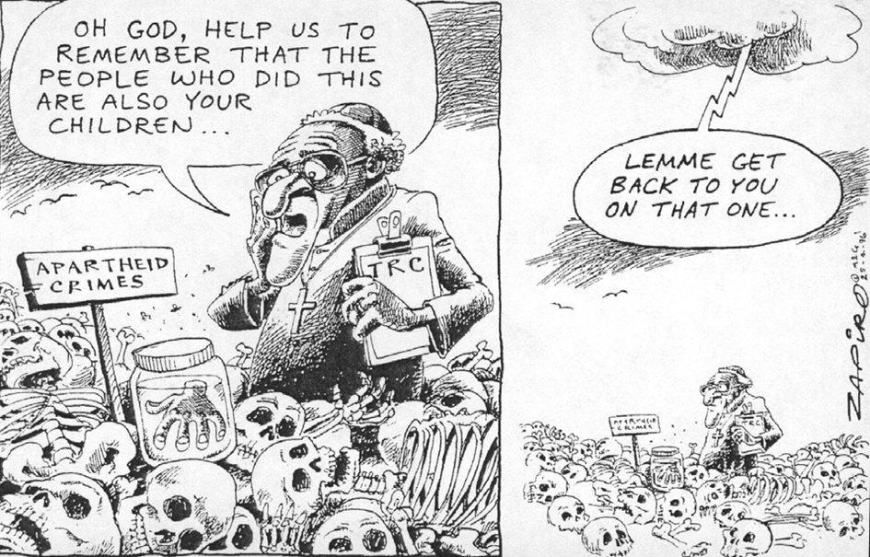
Document 2: “What should the daughter-in-law say?” by Ashmiti Gupta on his blog in a section entitled “Articles for Indian Children”., February 2015.

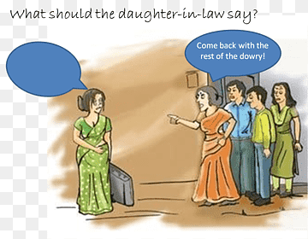

TRC stands for Truth and Reconciliation Commission, headed by Reverend Desmond Tutu. Zapiro is a white South African, the most famous South African political cartoonist born in Cape Town in 1958. Mail & Guardian are South African quality papers.

