**STUDENT’S IDENTITY:** _______________________________________________________________________

|  |
| --- |
| **EXAMINATION TIME: 3h30**  **Make sure you leave enough time for proofreading.**  **No documents nor technological devices allowed**  **TOTAL MARK:__________**/30 |

|  |
| --- |
| **PART 1 – LISTENING COMPREHENSION** |

_______/40:4: ________/10 marks

**INSTRUCTIONS:**

Do not open this question paper until you are told to do so. Write your full identity in the space provided for.

Listen to the instructions for each part of the paper carefully. Answer all the questions. While you are listening, write your answers on the question paper.

There are **fou**r **sections** to the listening test. You will hear each section **once only**. There are 40 questions. Each question carries one mark. For each part of the test, there will be time for you to look through the questions and time for you to check your answers.

**SECTION 1: Questions 1 - 10**

**Questions 1 – 5:**

Complete Tom’s Existing Customer Enquiry Form below.

Write **NO MORE THAN THREE (3) WORDS AND/OR A NUMBER** from the listening for each answer.

|  |
| --- |
| **Existing Customer Enquiry Form**  Date of Birth: (1) 12th March _______  Zip Code: 85823  House Number: (2) _____________  Customer’s Name: (3) Jennifer ____  Home Telephone: (4) 01934 __________  Monthly bill paid by (5) _______ |

**Questions 6 – 10:**

Complete Jennifer’s notes below.

Use **NO MORE THAN TWO WORDS AND / OR A NUMBER** from the listening for each answer.

|  |
| --- |
| Tom, the sales guy at R&N Mobile, said I would not get the extra (6) _____ of internet that I wanted, but he was able to issue a new contract, as the (7) ____________ had not been activated yet. The new deal has no extra costs and also gives access to the fast TFR Network.  I can still terminate the contract as long as I do it (8) ____ days in advance. The price of US$ (9) __ per month has not changed.  If I want to get a new cell phone, I can order one on the website – Tom will send me the (10) __ to the online store by email. I had to sign to reauthorize my payment. |

**SECTION 2: Questions 11 - 20**

**Questions 11 – 15:**

Choose **FIVE** letters, A – O.

Which of the following can be found in the Johnson Building?

A. Central coffee bar

B. The pizzeria

C. The French bistro

D. Asian Street café

E. The main reception

F. The finance office

G. The maintenance team office

H. The cinema

I. The first aid centre

J. The doctor’s surgery

K. The Fitness Area

L. The saunas

M. The steam rooms

N. The main swimming pool

O. The Internet café

**Questions 16 – 20:**

Complete the table below.

Write **NO MORE THAN THREE WORDS AND / OR A NUMBER** from the listening for each answer.

|  |  |  |
| --- | --- | --- |
| **Activity** | **Time** | **Notes** |
| Water Park Complex | 9 a.m. – 6 p.m. | £10 public  Reserved for holiday park (16) _____  from 9 a.m. to 12 noon. |
| Mini-golf | 9 a.m. – 6 p.m. | All equipment supplied; groups play at (17) _______ intervals. No cost. |
| Jogging | 8 a.m. or 5 p.m. | Morning jog easier – flat + (18) _____ km  approx. in length.  Afternoon jog harder – hillier + 6 km in length.  Both runs begin with gentle (19) ______ and finish with stretching. |
| Levington Excursion | Minibus departs park  at 1 p.m. + departs  Levington at 5 p.m. | Cost £2; buy at reception or from (20) __________; book early to avoid disappointment. |

**SECTION 3: Questions 21 – 25**

**Questions 21 – 25:**

21. What is the subject of Professor Norris’ seminar next week?

A. History

B. China

C. The students’ next essay

22. What is Alex’s course about?

A. How wild boars were re-introduced in the UK

B. How animals breed in different environments

C. How foreign species of animal affect environments

23. What was most responsible for reducing the number of UK wild boars until they totally

disappeared in the thirteenth century?

A. Disease

B. Too much hunting

C. A royal order for their extermination

24. What was the main problem with farming wild boars in the UK in the 1970s?

A. It did not make much money

B. The animals kept escaping

C. Hunters killed the animals

25. Why is the number of boars now probably more than 800?

A. More and more boars have escaped from farms

B. The escaped and released boars have bred

C. The Forestry Commission has released more boars to ensure healthy bloodlines

**Questions 26 – 30:**

Complete the summary below on the wild boars of the Forest of Dean.

Write **NO MORE THAN TWO WORDS** from the listening for each answer.

|  |
| --- |
| ***The Wild Boars of the Forest of Dean***  The wild boars of the Forest of Dean are now officially wild animals and the local (26) _________ is responsible for them.  Many locals say the high number of boars is not a problem. It’s reported that the (27) ____ will move the young away when they meet humans. Males are more aggressive, but only dogs have been chased.  The Forestry Commission now regularly kills boars to control numbers, but animal rights activists attempt to disrupt the (28) __________ doing this.  The Forest cannot be closed on cull days and activists patrol the (29) ________ where they know the culls take place to protect the animals. The forest rangers are upset, saying the boars create an imbalance in the forest. The rangers now try and kill the wild boars (30) __ dates. |

**SECTION 4: Questions 31 – 40**

**Questions 31 – 34:**

Complete the notes below.

|  |
| --- |
| **The New Zealand’s Exclusive Economic Zone (EEZ)**  New Zealand’s EEZ is the 5th largest in the world – covers approx. 3.9 million km².  New Zealand’s EEZ’s depth can be up to (31) ____ metres.  Underwater landscape of New Zealand’s EEZ includes mountains, valleys, geysers + mudflats. Much marine life grows there.  Fishing can damage sea life, especially with bottom trawl or dredge equipment.  Factors include: Type of seabed habit + the (32) _______ used.  **Bottom- Trawling**  Possibly the most destructive fishing type. Involves large nets being dragged over sea floor that take everything.  The unwanted species taken (called the (33) _________) are thrown back in sea, often dead or dying. This can be up to 90% of each trawl.  Conservationists claim sea floor life takes a long time to recover, if at all. This is disputed by (34) _______________. |

**Questions 35 – 37:**

Choose the correct letter **A, B, or C.**

35. Part of New Zealand’s fisheries management program is likened to

A. similar initiatives in other countries

B. similar initiatives on land

C. similar initiatives that were not implemented in the past

36. Most current BPA seabeds

A. have never had trawlers operating there

B. have been carefully charted by the New Zealand Ministry of Fisheries

C. Have been damaged by previous fishing

37. Charted hydrothermal vents

A. are difficult to locate for protection purposes

B. are key targets for the fishing industry

C. are closed to all fishing

**Questions 38 – 40**

Complete the sentences below.

Use NO MORE THAN THREE (3) WORDS AND / OR A NUMBER from the listening for each answer.

38. It’s claimed that more than ___ per cent of the New Zealand EEZ has never been subject to bottom trawling.

39. Conservation critics of the New Zealand government claim that not all vulnerable ___ are protected.

40. The work of industrial trawlers also affects the ____ of smaller communities, as the catches of their fishermen also suffer.

|  |
| --- |
| **PART 2 – READING (LECTURE)** |

_____/20 : 2: ________/10 marks

1. What is the Act of Union (when, who, what)? /1.5

____________________________________________________________________________________

1. What is the secular expression for the period of time prior to the birth of Jesus Christ? Give the full term and its abbreviation as well. /1

____________________________________________________________________________________

1. What is the Christian expression for the period of time subsequent to the birth of Jesus Chris? Give the full term and its abbreviation as well. /1

__________________________________________________________________________________________

What is devolution? Do give two examples of devolved powers in both Scotland (1 example) and Northern Ireland (1 example). /3

__________________________________________________________________________________________

1. How many times has the province of Quebec voted to decide whether or not it wanted to separate from Canada and become an independent country? Do say when. /1.5

_______________________________________________________________________________________

1. What is the origin of the name "Canada"? Do translate into English if necessary /1

__________________________________________________________________________________________

7. Who were the first people to live in Canada? /0.5

a. The First Nations Peoples

b. The Norsemen

c. The Vikings

d. The Americans

1. What proportion of India's population is untouchable? /0.5 _____________________________________ /0.5

____________________________________________________________________________________

1. What is the origine of the name "India"? /0.5 __________________________
2. Who / What was instrumental in propagating Islam in India? /0.5 ______________
3. The Indian subcontinent is the birthplace of four of the world's major religions. Besides Hinduism and Buddhism, what are the other two? /1

_______________________________________________________________________________________

1. Which Indian city is known as the “Silicon Valley of India" for its large high-tech industry? /0.5

a. Mumbai

b. New Delhi

c. Jaipur

d. Bangalore

13. Which of the following best describes India's government? /0.5

a. A direct democracy

b. A constitutional monarchy

c. A socialist republic

d. A parliamentary republic

1. What does *Terra nullius* stand for? /0.5 _ ___________________________________________________
2. What is the meaning of “Australia”? /0.5

a. South land

b. North land

c. East land

d. West land

1. Who was the first European to land on Natal coast? /0.5

a. Bartholomeu Dias

b. Jan Van Rubeck

c. Vasco da Gama

17. South Africa divides its governmental power among three capitals. There is a judicial capital, an administrative capital and a legislative capital. Which one of the following is the judicial capital of South Africa? /0.5

a. Durban

b. Pretoria

c. Cape Town

d. Bloemfontein

e. Johannesburg

1. How many official languages does South Africa have? /0.5 ________________________

19. The Republic of Ireland and Northern Ireland form a single country: true or false? /0.5________

20. In history, what does the British expression “The Troubles” refer to? /1.5

__________________________________________________________________________________________

21. Name two Scottish tribes at the time the Romans tried to conquer today’s Scotland /1

_________________________________________________________________________

22. List countries where English is spoken as an official language /1

* 1. 2 African countries: ____________________________________________________________
  2. 2 Caribbean countries: __________________________________________________________

|  |
| --- |
| **PART 3: WRITING** |

|  |  |
| --- | --- |
| **GRADING SECTIONS** | **TOTAL MARK : _____/20 :2**  **_________/10** |
| **INTRODUCTION**: Contextualisation (background information the reader needs  to know to understand the historical meaning of this document) + Presentation of  document + problematic + plan of your commentary. | **/3** |
| **BODY:** Each of several parts clearly introduced and structured: main idea of the  part + how the cartoon backs this idea + reference to the document + your personal interpretation/commentary of this idea/message (what is the main message here?  What happened before/after...? What can one infer?) | **/9** |
| **CONCLUSION:** General recapitulation of body + personal assessment and  justification(s) + Introduction of larger debate. | **/2** |
| **GRAMMAR:** Accuracy, Complexity and Range | **/3** |
| **VOCABULARY:** Accuracy, Complexity and Range | **/3** |

**Suggest a structured and an argumentative commentary of ONLY ONE of the following documents:**

**Document 1: “The TRC”,** by Zapiro, in *Mail* & *Guardian*, 2000[1]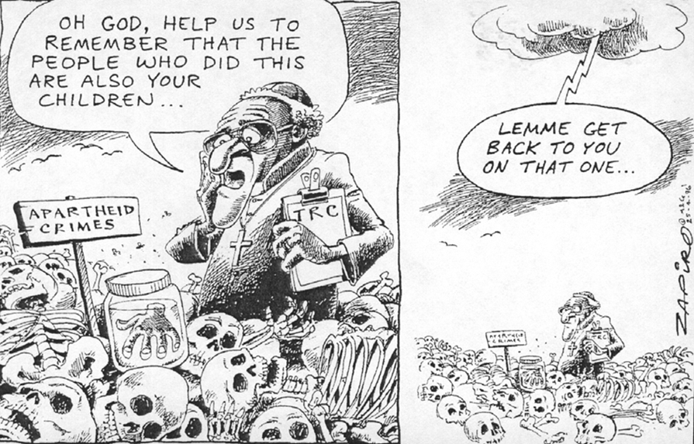

**Document 2: “Marriage or Prostitution: How Can You Possibly Price the Priceless?”** by Kunal Thakore, an Indian lawyer, published on his blog in May 2017.

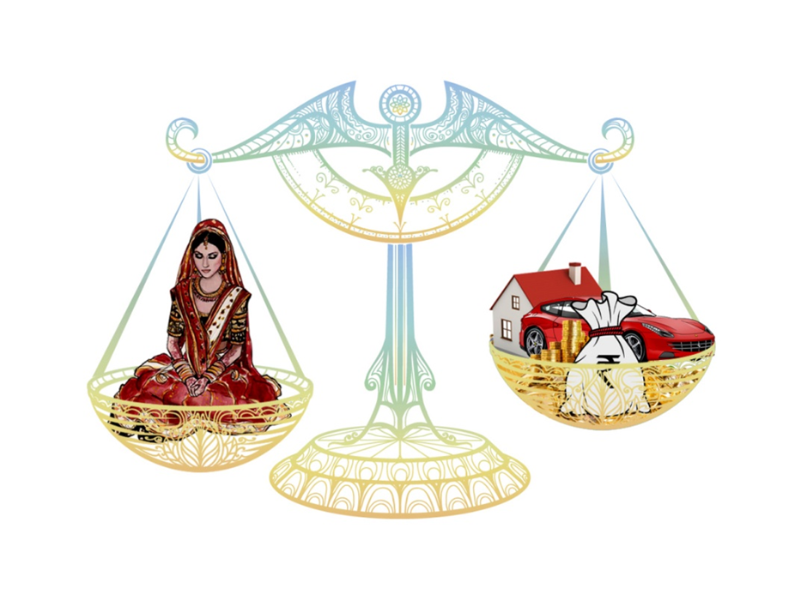

**Text as published with the document:**

**Girl is dark?** – Give more dowry (we have an obsession for ‘gora’ or fairness)

**Girl can’t cook?** – Ay yai yo. Disaster in making. Add one crore[2] (“ai yai yo” = “oh no!”. 1 crore = 10

million rupees[3])

**Convent educated girl?** – Better speaking English will not do. No, no, boy feels insecure, hurts his and his parents’ big ego.

**Boy is an engineer?** – Very much smartest. Increased value in marriage market.

**Different caste?** - How it can be? It is most horrible.

**“Gifts” are exchanged, deal is done. Poor bride father exhausted lifelong savings. Now who will pay for all guests arriving?** – It’s the bride’s family to pay for the entire wedding.

And before that, one minute wait! Pandit (Hindu priest) and 500 relatives to be fed. Only then giving blessings.

1. Zapiro is a white South African, the most famous South African political cartoonist born in Cape Town in 1958.

   *Mail & Guardian* are South African quality papers.
2. A crore is a unit of measurement commonly used in India, Bangladesh, Nepal, and Pakistan to represent 10 million.  It’s derived from the Sanskrit word “koti,” which means ten million.
3. 1 EUR = ₹88,6132 (Indian Rupee, ₹)

   ₹1 = a stamp; ₹1 = a washing powder mini sachet; Average Monthly Net Salary (After Tax): between ₹15,000 and ₹20, 000.