***EI05: An Introduction to Innovation Studies***

***NAME: _____________________________________________***

***SURNAME: _________________________________________***

***Part 1. (20 points)***

***Please answer clearly and briefly to the following questions:***

**1. Recall and define the four types of innovation considered by the OSLO Manual.**

_____________________________________________________________

_____________________________________________________________

_____________________________________________________________

_____________________________________________________________

_____________________________________________________________

_____________________________________________________________

_____________________________________________________________

_____________________________________________________________

_____________________________________________________________

_____________________________________________________________

**2. Explain the epidemic diffusion pattern (i.e. the S-curves) that can be observed for most of innovations.**

_____________________________________________________________

_____________________________________________________________

_____________________________________________________________

_____________________________________________________________

_____________________________________________________________

_____________________________________________________________

_____________________________________________________________

_____________________________________________________________

_____________________________________________________________

_____________________________________________________________

**3. Discuss briefly the relationship between the nature of knowledge and the nature of interactions in a `System of Innovation'.**

_____________________________________________________________

_____________________________________________________________

_____________________________________________________________

_____________________________________________________________

_____________________________________________________________

_____________________________________________________________

_____________________________________________________________

_____________________________________________________________

_____________________________________________________________

_____________________________________________________________

**4. Recall the two main mechanisms of Economic Growth. How does innovation relate to those ?**

_____________________________________________________________

_____________________________________________________________

_____________________________________________________________

_____________________________________________________________

_____________________________________________________________

_____________________________________________________________

_____________________________________________________________

_____________________________________________________________

_____________________________________________________________

_____________________________________________________________

**5. Comment the following graph:**

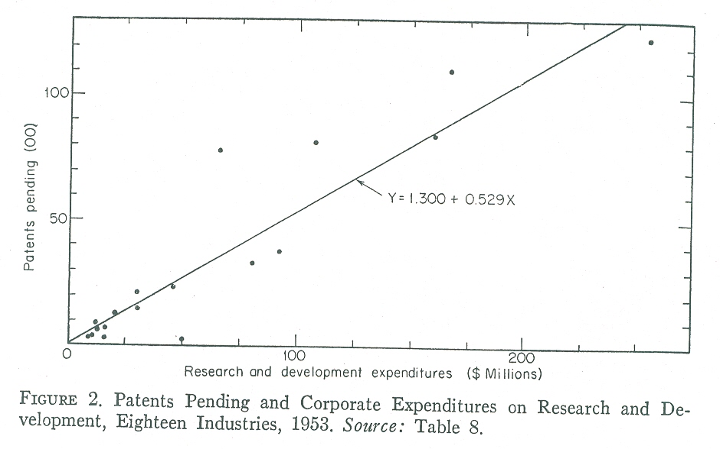

*sources: Schmookler "Inventions and Economic Growth" 1953.*

_____________________________________________________________

_____________________________________________________________

_____________________________________________________________

_____________________________________________________________

_____________________________________________________________

_____________________________________________________________

_____________________________________________________________

_____________________________________________________________

_____________________________________________________________

_____________________________________________________________

_____________________________________________________________

_____________________________________________________________

_____________________________________________________________

_____________________________________________________________

_____________________________________________________________

_____________________________________________________________

_____________________________________________________________

_____________________________________________________________

_____________________________________________________________

_____________________________________________________________

***NAME: _____________________________________________***

***SURNAME: _________________________________________***

***Part 2. (20 points)***

1. Explain this picture. What does it mean? What is the underlying theoretical approach? Could you give an example to illustrate this approach? (12 points)



1. What does frugal innovation change in innovation process thinking? (8 points)

***NAME: _____________________________________________***

***SURNAME: _________________________________________***

***Part 3. (20 points)***

1. **AIR TRANSPORT MANAGEMENT**

The Chinese aircraft manufacturer COMAC has designed a new commercial jet named C-919.

Is COMAC’s entry into the aircraft market a threat for Airbus and Boeing?

1. **REVERSE INNOVATION**

Why does reverse innovation get so much attention? Is reverse innovation likely to change the rule of the game in the coming years in international business ?

***NAME: _____________________________________________***

***SURNAME: _________________________________________***

***Part 4. (20 points)***

Technical experts are reasonably good at anticipating the kinds of performance improvements that can be teased out of a given technology, once it has been established and its working principles are reasonably well understood. Technical specialists usually have good appreciation of likely improvement trajectories […]. Why, then, the poor performance in dealing with the future impact of new technologies? […] The impact of new or improved technologies is not just a matter of improved technical performance. It is, rather, a matter of translating such information into its potential economic and social significance. Doing this requires something much more than purely technical expertise […]. The point is that social change or economic impact is not something that can be extrapolated out of a piece of hardware. New technologies are, rather, building blocks. Their eventual impact will depend on what is subsequently designed and constructed with them. New technologies are unrealized potentials that may take a very large number of eventual shapes. What shapes they actually take will depend on a wide range of social priorities and values, or the way the demand for particular goods and services change in response to rising incomes or declining prices.

N. Rosenberg, “The impact of technological innovation: an historical view”, in R. Landau and N. Rosenberg (eds.), *The Positive Sum Strategy. Harnessing Technology for Economic Growth*, Washington, National Academy Press, 1986, p. 25-26.

Explain, comment and discuss this point of view on the understanding of technological change and its connection with the economics. Please argue with the support of examples.