Grade: … /80 … /30

Signature: ……………….

- Vocabulary:……./10

- Grammar:……/20

- Reading comprehension:……./20

- Writing:……../ 30

LE05 Business English Final Written Exam Autumn 2013
- Vocabulary /10
Business & Finance : Complete this crossword puzzle
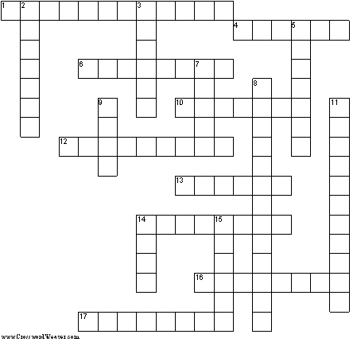

N.B. There are no spaces between words.
Across | Down
1. rate and efficiency of work  4. ask the bank to advance money  6. money paid for a loan  10. wealth of person or business  12. A promise to repair or replace a product  13. amalgamation of two companies  14. legal agreement  16. total sales of a company  17. share of profits paid to shareholders | 2. proof of payment  3. to put money into a company or business  5. money paid to owner of copyright or patent  7. part of the capital of a company  8. where shares are bought and sold  9. money lent  11. amount of money spent  14. neither cheque nor credit card  15. money returned
1
LE05 Business English Final Written Exam Autumn 2013

II) Grammar : /20

1.Third Conditionals :
Complete this conversation using the correct form of the verbs in brackets :
CRISTINA : So why do you think the project was so unsuccessful ?
JEFF : Looking back, there were so many mistakes. If we 1 had started (start) the project in January
instead of May, we 2……………………………. (be able to) launch at the right time for the buying
season.
CRISTINA : OK, but I heard there were delays in sending out stock even once the project was established.
JEFF : Well, yes, we had lots of problems organising the packing line.
CRISTINA : I see, 3……………………………. (you/get) more stock out into the market on time with
a better-organised packing line ?
JEFF : Maybe. I think that’s something that we should look at in future projects.
CRISTINA : What about the communication problems ? 4……………………………. (it/help) if
more people 5……………………………. (take) Spanish classes before moving to the Guatemala
office ?
JEFF : Well, as you know, I studied Spanish for several months before moving. I certainly think it
6……………………………. (be) difficult to communicate with my clients if I
7…………………………….(not/know) any Spanish.
CRISTINA : It’s really important to learn from our mistakes this time. If we
8……………………………. (learn) the lessons from our previous ventures in Latin America, we
9……………………………. (not/have) so many problems establishing the business in Guatemala.
JEFF : Yes, if we 10……………………………. (have) more support from our other offices, the
project probably 11……………………………. (succeed).

2

LE05 Business English Final Written Exam Autumn 2013

2 .Gerunds vs To +BV :
Complete this conversation between two colleagues about a competitor.Use the correct form of the verbs in brackets :

ALAN : Any news of Mounts ? Are they managing 1 to take much business from us ?
TIM : I’d say that around here we’re still doing ok.Customers tend 2……………………….. (come) to
us first.But we’ve ended up 3…………………….. (lose) customers in Scotland because that’s always
been their area.
ALAN : So, should we spend a lot of time 4……………………….. (try) to win back that business ?
TIM : I’d say not,no.We decided 5……………………….. (focus) on other areas for now so that we
can concentrate on 6……………………….. (build) our business round here.We can’t afford
7……………………….. (ignore) the local area.
ALAN : I guess Mounts have considered 8 ……………………….. (move) into our area
here,though.Are they still relying on 9……………………….. (be) the cheapest ?
TIM : Yeah.If they do target this area, I expect 10……………………….. (get) a lot of calls from
customers about prices. It’s a worry.
ALAN : Well,we’ll just have to keep 11……………………….. (offer) a better service.

3
LE05 Business English Final Written Exam Autumn 2013

III) Reading comprehension / 20
Text : Four styles of corporate leadership
Read this article from the Financial Times by Diane Summers and answer the questions on page 5

4
LE05 Business English Final Written Exam Autumn 2013

Read the article from the Financial Times by Diane Summers and answer the questions :

- Each of the statements a-d was made by someone with one of the four management styles in the article. Match each statement with the management style of the person who said it.

- I believe in delegating responsibility as much as possible. I try to be open and trusting towards the people I work with. I leave detail to my managers and focus on longer-term strategy, rather than day-to-day operations. I get on really well with non-executive directors.
Person who said that :……………………..

- I’m really interested in what motivates people and I try to balance emotional issues with intellectual ones. I think it is really important to get on with other people and understand their concerns. I try and support the people I work with as much as possible.
Person who said that : ……………………..

- I work very closely with the CEO and we make a great team. I have very clear and strong views about what needs to be done, but I don’t always tell people what they are ! I have respect for the people I work with, and I expect them to respect me.
Person who said that : ……………………..

- I need people who think about the company 25 hours a day. I’m the boss round here.All this stuff about the chair and the CEO being equals is nonsense ! I believe in having a clear strategy and carrying it through. Once a strategy is decided, continual analysis of what we’re doing is not helpful.
Person who said that : ……………………..

5

LE05 Business English Final Written Exam Autumn 2013

- Decide whether these statements are True or False and correct the False ones by quoting from the text (lines 1-14):

- CGC has its headquarters in London : ……………….
………………………………………………………..

- All the board members to whom a questionnaire was sent replied : ……………….
………………………………………………………..

- All the people who were interviewed completed a questionnaire: ……………….
………………………………………………………..

- The board members all come from companies whoses shares are listed on the London stock market: ……………….
………………………………………………………..

- More chief executives than chairs were interviewed: ……………….
………………………………………………………..

- Find expressions in line 47-83 that mean:

- When you support your organisation and do nothing to harm it (1 word):
……………….

- When you spend a lot of time understanding figures, facts,etc (2 words):
……………….

- When you put all your energy into the company you work for (1 word):
……………….

- When you have a clear idea of what the future will be like (1 word):
……………….

- The way you relate to different people (1 word):
……………….

- Strength of character (3 words):
……………….

6
LE05 Business English Final Written Exam Autumn 2013
IV) Writing:
In your opinion which characteristics in order of importance are necessary to be a good CEO, give reasons for the order you choose (for instance: intellectual brilliance, strategic sense, talented communicator etc…)
Write at least 200 words. points will be taken off if the essay is too short
Grading scheme:
Structure /4
Content /12
Grammar /7
Vocabulary /7

7

